INTODUCTING A NEW PARADYGM IN URBAN PLANNING THROUGH THE LENSE OF LIFE

AP 406
DISSERTATION REPORT
2024-2025

SAFIR ABBAS ZAIDI
01659301621
FOURTH YEAR


GURU GOBIND SINGH INDRAPRASTHA UNIVERSITY



Affiliated to
Guru Gobind Singh Indraprastha University
Dwarka, New Delhi

MBS SCHOOL OF PLANNING AND ARCHITECTURE
SECTOR 9, DWARKA, NEW DELHI
CANDIDATE’S DECLARATION

I hereby certify that the work which is being presented in the Dissertation Report entitled “INTODUCTING A NEW PARADYGM IN URBAN PLANNING THROUGH THE LENSE OF LIFE” is a part prerequisite to the award of the degree of Bachelor of Architecture, at MBS School of Planning and Architecture, under GGSIP University. It is an authentic record of my own work carried out during a period of January 2025 to April 2025.

The matter presented in this Dissertation report has not been submitted by me forth award of any other degree of this or any other Institute.

DISSERTATION COORDINATOR NAME

Prof. Alpana Rastogi

Ar. Kriteeka

This is to certify that the above statement made by the candidate is correct to the best of my knowledge.

Date:

.........................
Director MBS SPA

ACKNOWLEDGMENT

I would like to express my deepest gratitude to everyone who has supported and guided me throughout the course of this dissertation titled " INTODUCTING A NEW PARADYGM IN URBAN PLANNING THROUGH THE LENSE OF LIFE."

I am deeply thankful to Ar. Kriteeka for her consistent guidance, valuable insights, and encouragement at every stage of this research. Her expertise and feedback helped me maintain clarity and direction in my study. I also extend my heartfelt appreciation to Prof. Alpana Rastogi, whose academic mentorship, constructive critique, and support were vital in shaping the theoretical and contextual foundation of this dissertation. Their combined support has been instrumental in helping me translate my ideas into meaningful research.
I am equally grateful to the faculty members of MBS School of Planning and Architecture, whose guidance throughout my academic journey provided the foundation for this research.
My sincere appreciation goes out to my classmates and friends for their support, camaraderie, and thoughtful discussions, all of which greatly enriched my perspective. Above all, I owe heartfelt thanks to my family for their unwavering support, patience, and belief in me throughout this endeavour.
This dissertation is a product of the collective support, inspiration, and encouragement I have received, and I am truly thankful to everyone who played a role in its realization.

Safir Abbas Zaidi
Bachelor of Architecture
MBS School of Planning and Architecture

ABSTRACT

This research proposes a paradigm shift in urban planning through the lens of Life-Centric Urbanism, a framework that prioritizes ecological interdependence, multispecies cohabitation, and regenerative design principles. In response to the ecological and psychological detachment induced by conventional anthropocentric urban models, this study critically repositions the city as a complex living ecosystem one that must honour, integrate, and adapt to the needs of both human and more-than-human life.
Drawing from theoretical models of ecological urbanism, biophilic design, and nature-based solutions (NBS), the research interrogates current planning paradigms by evaluating global precedents from Singapore, Amsterdam, and Freiburg. It introduces a Life-Centric Urbanism Index (LCUI) comprising five key domains: biodiversity integration, multispecies infrastructure, ecological functionality, human-nature relationships, and governance metrics. These are assessed using measurable indicators such as habitat connectivity, species presence, soil health, and environmental literacy.
Aligned with the UN Sustainable Development Goals (SDGs) particularly SDG 11 (Sustainable Cities), SDG 13 (Climate Action), and SDG 15 (Life on Land) the study advances implementable design and policy strategies that regenerate fragmented ecosystems, mitigate climate vulnerability, and democratize access to nature. The research critiques technocratic approaches that commodify green infrastructure while ignoring relational, place-based definitions of nature, and instead promotes radically relational urbanism that fosters emotional, sensory, and ethical connections between humans and non-humans.
By advocating for participatory, site-sensitive, and post-anthropocentric design processes, this work contributes to the evolving discourse on ecological justice, urban resilience, and the co-evolution of culture and nature. It offers a replicable model for cities aiming to transition from sustainability as maintenance toward sustainability as mutual flourishing.

TABLE OF CONTENT

CHAPTER 1 INTRODUCTION 1
1.1 Overview 1
1.2 Background 2
1.3 Rationale 3
1.4 Research Aim and Objectives 4
1.4.1 Research Aim 4
1.5 Limitations of the Research 4
1.6 Research Methodology 6
CHAPTER 2 REVIEW OF EXISTING PLANNING PARADIGMS 7
2.1 Garden city model 7
2.2 Concentric Zone Model 9
2.3 Transit-Oriented Development (TOD) 11
2.4 Smart Cities Mission 12
2.5 Critique: Fragmentation, Inequity, Anthropocentrism 13
2.6 Missed Opportunity: Nature as Passive Background, Not Active Agent 15
CHAPTER 3 THEORETICAL FRAMEWORK 17
3.1 Ecological Urbanism City as Ecosystem 17
3.1.1 Introduction to Ecological Urbanism 17
3.1.2 Key Principles and Theoretical Foundations 18
3.1.3 Contributions to Life-Centric Urbanism 18
3.1.4 Exemplary Case Studies and Projects 19
3.1.5 Limitations and Critique 19
3.1.6 Toward Life-Centric Integration 19
3.2 Biophilic Urbanism – Multisensory, Health-Enhancing Design 20
3.2.1 Introduction to Biophilic Urbanism 20
3.2.2 Principles and Design Strategies 20
3.2.3 Empirical Benefits and Global Practices 21
3.2.4 Critique and Limitations 21
3.2.5 From Biophilia to Multispecies Urbanism 22
3.3 Nature-Based Solutions (NBS) – Critique of Vague “Nature” 22
3.3.1 Introduction to Nature-Based Solutions 22
3.3.2 The Four Natures of NBS 22
3.3.3 Instrumentalism and Anthropocentrism in NBS 23
3.3.4 Challenges in Localizing and Contextualizing Nature 23
3.3.5 Governance and Equity Concerns 24
3.3.6 From Nature-Based to Life-Centric 24
3.4 Posthumanism & Relational Design – Multispecies Ethics, Co-Evolution 24
3.4.1 Introduction: Beyond the Human-Centred City 24
3.4.2 Multispecies Urbanism and Shared Agency 25
3.4.3 Relational Design Thinking: From Objects to Networks 25
3.4.4 Ethics of More-Than-Human Inclusion 26
3.4.5 From Control to Co-Evolution 26
3.4.6 Conclusion: Posthumanism as a Framework for Ethical Urban 26
CHAPTER 4 SINGAPORE CASE STUDY: INTEGRATING GREEN INFRASTRUCTURE AND BIODIVERSITY 27
4.1 Introduction 27
4.2 Eco-Link@BKE: A Model for Ecological Connectivity 27
4.3 Gardens by the Bay: Urban Biodiversity and Public Engagement 28
4.4 Bishan-Ang Mo Kio Park: River Naturalization and Community Spaces 28
4.5 Alignment with LCUI Indicators 28
CHAPTER 5 CRITIQUE OF CURRENT FRAMEWORKS 29
5.1 Nature as a Service: A Problem of Value Framing 29
5.2 Greenwashing through Nature-Based Solutions 29
5.3 Absence of Multispecies Rights and Stewardship Policies 30
5.4 Flattening Complexity: Geometry without Ecology- 30
5.5 Toward a Life-Centric Reorientation 31
CHAPTER 6 THE LIFE-CENTRIC URBANISM FRAMEWORK 31
6.1 Guiding Principles: Empathy, Continuity, Cohabitation, Feedback 31
6.2 Five Structural Pillars of the LCUI 32
6.2.1 Ecological Continuity 32
6.2.2 Multispecies Infrastructure 32
6.2.3 Regenerative Systems 33
6.2.4 Human–Nature Relationships 33
6.2.5 Governance & Ethics 34
CHAPTER 7. BENCHMARKING AND EVALUATION METRICS 39
7.1 LCUI Indicator Matrix 39
7.2 Hypothetical Application: Delhi, Pune, and Bangalore 41
7.3 Comparison with LEED, GRIHA, and Smart City KPIs 42
7.4 Toward Visual Dashboards and Urban Life Reports 42
CHAPTER 8 CRITICAL REFLECTIONS AND THEORETICAL SIGNIFICANCE 46
8.1 Limits: Over-Idealism, Data Gaps, and Market Conflict 46
8.2 Epistemological Shift: From Function to Co-Evolution 46
8.3 Original Contribution: A Measurable Ecological Ontology 47
CHAPTER 9 CONCLUSION 48

CHAPTER 1 INTRODUCTION

1.1 Overview
As cities continue to sprawl and intensify, the planet finds itself amid an escalating ecological and existential crisis. Urban expansion now accounts for the fragmentation of habitats, increased carbon emissions, biodiversity collapse, and the disruption of hydrological and nutrient cycles. The Anthropocene the current epoch characterized by human dominance over Earth’s systems has exposed a central failure of contemporary urbanism: it has prioritized human convenience and economic efficiency at the expense of the complex interdependencies that sustain life. This failure is not incidental; it is structurally embedded in the prevailing models of city planning.
The dominant paradigms of urban development zoning-based masterplans, technocratic smart cities, and growth-oriented transit systems remain locked within anthropocentric logics. Whether it is the Le Corbusier-inspired functional zoning of modernism or the algorithmic optimization of “smart urbanism,” urban planning has long regarded non-human nature as a passive backdrop, to be managed or mitigated rather than integrated and co-evolved with. Even well-intentioned frameworks such as sustainable development and nature-based solutions (NBS) risk reducing ecosystems to service providers, whose value is framed through ecosystem services rather than their intrinsic rights to exist and regenerate. As Cabanek et al. (2020) caution, such approaches often emphasize aesthetics, carbon credits, and utility, while neglecting the deeper ecological and relational dynamics essential for planetary health.
This paper argues that current urban planning models are ill-equipped to meet the challenges of the climate crisis, biodiversity collapse, and deepening social inequality. What is needed is a new urban epistemology one that recognizes cities not merely as machines for living but as living ecosystems themselves. To move beyond the reductionist dualism of “nature vs. city,” we propose Life-Centric Urbanism: a paradigm that places the flourishing of all life forms human and more-than-human at the centre of urban planning, design, and governance.
Life-Centric Urbanism (LCU) is not a stylistic movement or a technical toolkit. It is a radical reorientation of urbanism based on the understanding that cities are embedded in, dependent on, and co-constitutive of ecological systems. Drawing upon the theoretical underpinnings of Ecological Urbanism (Mostafavi & Doherty, 2010), the restorative potential of Biophilic Urbanism (Kellert, Beatley, Cabanek et al.), and the critiques of Nature-Based Solutions presented by Oliveira (2025), Life-Centric Urbanism extends the urban agenda from efficiency to empathy, from land-use to life-support. It sees cities as ecotones transitional, dynamic, and multispecies spaces—where policy, infrastructure, and design coalesce to regenerate the conditions that make life possible.

What sets Life-Centric Urbanism apart is its operational framework. It proposes a measurable, implementable model through the Life-Centric Urbanism Index (LCUI a set of indicators and thresholds that assess how well a city supports biodiversity continuity, multispecies infrastructure, ecological function, environmental justice, and feedback-driven governance. Unlike traditional green building certifications or sustainability checklists, LCUI does not treat ecology as an afterthought; it positions ecological integrity and relational wellbeing as prerequisites for any urban intervention.
This research paper is structured in three primary segments. First, it conducts a critical review of the evolution of town planning paradigms from early industrial zoning to smart cities highlighting their ecological blind spots and systemic shortcomings. Second, it consolidates theoretical foundations from ecological urbanism, biophilic design, and nature-based planning, while exposing their current limitations. Third, it presents the Life-Centric Urbanism model, detailing its five structural pillars, spatial application, and policy implications. The paper concludes with an evaluation of its theoretical significance and pathways for implementation through adaptive governance and ecological zoning.
By shifting the unit of planning from human land-use to multispecies coexistence and interdependent systems, this paper calls for a planning revolution. Life-Centric Urbanism is not merely a reaction to environmental degradation it is a regenerative proposition. It envisions cities where rivers are not buried but celebrated, where soil health is tracked like GDP, and where architecture responds not only to codes but to kinship. As urbanization continues to define the human future, only a planning model that honours all life will be truly sustainable

1.2 Background
Urbanization, the defining characteristic of the 21st century, has fundamentally reshaped landscapes, ecosystems, and human-nature relationships. While traditional urban planning models—rooted in modernist, functionalist, and economically driven paradigms have succeeded in organizing cities for human utility, they have largely marginalized natural systems, biodiversity, and ecological processes. Cities have expanded by fragmenting habitats, channelizing rivers, paving over fertile soils, and isolating non-human life into ornamental pockets rather than integrating it into living urban systems.
As urban sprawl intensifies, global challenges such as biodiversity collapse, climate instability, water scarcity, urban heat islands, and ecosystem fragmentation have become alarmingly prevalent. Conventional models, focused predominantly on economic growth and social infrastructure, have proven insufficient to address these systemic vulnerabilities. They fail to conceptualize cities as ecological systems and largely ignore the rights of non-human species to coexist within urban fabrics.
Recent shifts in theory such as ecological urbanism, regenerative design, and multispecies urbanism highlight the urgency to reframe urban planning not just as human-centred engineering, but as a dynamic negotiation between people, ecosystems, and planetary health. Cities must now be reimagined as life-supporting systems capable of regenerating biodiversity, sustaining natural cycles, and fostering multispecies cohabitation alongside human societies.
Singapore, Amsterdam, Curitiba, Freiburg, and Melbourne showcase how integrating biodiversity corridors, green-blue infrastructure, vertical forests, sponge city principles, and inclusive ecological zoning can create cities that are resilient, liveable, and restorative. These cities provide critical precedents demonstrating that ecological integration is not an aesthetic luxury—it is a survival imperative.
Thus, a paradigm shift is needed: a move from anthropocentric, zoning-heavy models to adaptive, life-centric urban planning frameworks that view cities as cohabitation grounds for all life forms, not just humans.

1.3 Rationale
Before the onset of industrialization (~1750–1850), cities were relatively modest in scale, tightly bound to their surrounding ecosystems, and shaped by natural constraints such as water availability, soil fertility, and topographical conditions (Rees, 1992). Urban metabolism was predominantly local: food, water, and building materials were sourced from nearby regions, and waste was often cycled back into agricultural or ecological systems. Human settlements were compact, and although not always ecologically sustainable, they maintained a tangible, immediate relationship with the natural environment.
In this pre-industrial paradigm, rivers, wetlands, forests, and wildlife were integral to the urban fabric, not segregated into “green spaces.” Cities evolved around natural flows rather than imposing engineered infrastructures upon them. However, vulnerabilities persisted: floods, fires, disease outbreaks, and resource scarcity were common, as societies lacked technological means to fully control their environments.
The Industrial Revolution marked a radical rupture. Mechanization, fossil-fuel dependency, and the rise of industrial capitalism allowed cities to decouple from local ecological limits (Cronon, 1991; Merchant, 1980). Urban centers exploded in scale, drawing resources from global hinterlands, disrupting indigenous ecosystems, and reshaping landscapes to prioritize economic production over ecological stability.
This transformation led to profound consequences for both human societies and natural systems:
For Humans:
- Industrial cities like Manchester and Birmingham became hotspots of pollution, overcrowding, and public health crises (Engels, 1845).
- Access to nature diminished drastically; green spaces were relegated to decorative parks for elites, severing daily human-nature contact (Simmel, 1903).
- Alienation, environmental injustice, and socio-ecological inequities intensified in rapidly expanding urban centres.
For Nature:
- Ecological degradation surged—deforestation, river pollution, soil exhaustion, and mass extinction trends accelerated (Steffen et al., 2015).
- Habitat fragmentation became ubiquitous as transport infrastructure, factories, and sprawl dissected once-continuous ecosystems.
- The balance of biogeochemical cycles, including carbon and nitrogen flows, was fundamentally altered at a planetary scale.
Industrial urbanization introduced an urban model where nature was externalized, commodified, and subordinated to human economic imperatives. Cities evolved as infrastructure-driven machines for consumption and growth, disembedded from their ecological foundations (Wolch, 1996).
Understanding this historical disjuncture is crucial. It highlights that the anthropocentric, extractive planning models dominant today are not inevitable—they are products of specific socio-technological transitions. Therefore, it is both possible and necessary to rethink urban planning paradigms: to transition from exploitative, industrial-era logics toward regenerative, life-centric urbanism that restores ecological cohabitation, resilience, and planetary health.
This research builds on this imperative by proposing town planning frameworks, spatial models, and policy pathways that re-anchor cities within the web of life.

1.4 Research Aim and Objectives

1.4.1 Research Aim
This research aims to introduce a new paradigm in urban planning through the lens of life, by developing context-sensitive town planning models, spatial frameworks, and policy strategies that prioritize ecological integrity, multispecies cohabitation, and regenerative urban systems. It seeks to shift contemporary urban planning away from anthropocentric, infrastructure-driven models toward life-centric urbanism that embeds biodiversity, resilience, and nature-based solutions into the very foundation of urban growth and governance.
The goal is to conceptualize and operationalize life-centric planning as a measurable, adaptable, and scalable model suitable for cities facing varying degrees of urbanization and habitat fragmentation, particularly in the Indian context.

1.5 Limitations of the Research
While this research aspires to propose a comprehensive and transformative paradigm for life-centric urban planning, certain inherent limitations must be acknowledged:
- Interdisciplinary Breadth and Depth: This study integrates multiple theoretical frameworks—including Ecological Urbanism, Regenerative Urbanism, Biophilic Design, and Multispecies Urbanism—to build a holistic life-centric approach. However, the wide disciplinary breadth may limit the depth with which each theoretical strand is critically contested and operationalized within the given scope and timeframe.
- Contextual Specificity and Generalization: The proposed planning models are categorized based on degrees of urbanization intensity and habitat fragmentation. Nevertheless, cities are socio-ecologically complex and vary by governance structures, cultural contexts, political economies, and biophysical conditions. Therefore, while the models provide adaptable frameworks, further localized adaptation and empirical validation would be necessary beyond the scope of this study.
- Data Availability and Reliability: The construction of the Life-Centric Urbanism Index (LCUI) and the ecological diagnostics rely predominantly on secondary datasets, including GIS layers, biodiversity inventories, and land-use plans. In many Indian cities, ecological datasets are either incomplete, fragmented, or outdated, which may affect the precision of spatial assessments and analysis outcomes.
- Implementation Challenges: The proposed planning frameworks, zoning regulations, and governance reforms remain largely conceptual within the study. Actual implementation would depend on factors such as political will, administrative capacity, regulatory reform, and stakeholder engagement—dimensions that are beyond the immediate purview and timeline of this academic research.
- Temporal Constraints and Long-Term Validation: Ecological regeneration, multispecies infrastructure integration, and systemic resilience building are inherently long-term processes. Due to the limited timeframe of the academic semester in which this research must be completed, longitudinal field studies or monitoring of ecological outcomes could not be conducted. Therefore, the study remains predictive and framework-oriented, proposing models for future empirical testing and adaptation.
- Geographical and Cultural Focus: While the research draws insights from international best practices (e.g., Singapore, Freiburg, Melbourne), its primary focus remains on Indian cities. As such, the proposed frameworks may require contextual recalibration when applied to cities in other global regions with different governance systems, cultural patterns, or ecological baselines.
- Technological Infrastructure Assumptions: Some analytical methods, such as GIS-based auditing, biodiversity performance tracking, and multispecies spatial mapping, assume a foundational level of technological capacity within municipal planning agencies. Cities with technological or infrastructural deficits may face challenges in fully operationalizing such assessment tools.

1.6 Research Methodology
This research adopts a qualitative and exploratory approach aimed at proposing new life-centric town planning models and policies that integrate ecological regeneration, multispecies cohabitation, and urban resilience. The study is primarily theoretical, and design-research driven, supported by case study evaluations, spatial analysis, and the creation of a measurable Life-Centric Urbanism Index (LCUI). The research design is structured into four major phases:
- critical literature review,
- development of analytical frameworks (LCUI),
- case study analysis of selected cities (e.g., Singapore, Freiburg), and (iv) formulation of typology-based planning models and policy recommendations.
Data collection is primarily based on secondary sources, including academic books, journals, government policy documents, urban master plans, biodiversity strategies, and GIS-based datasets. Reputable academic databases such as ResearchGate, ScienceDirect, and SpringerLink, along with official municipal websites and planning authorities (e.g., NParks Singapore, URA), have been used to collect credible data. Due to the limited timeframe of the academic semester, no primary fieldwork (such as interviews or surveys) is conducted. However, GIS-based spatial analysis and LCUI-based city evaluations are applied wherever relevant data is available.
Analytical methods involve a critical examination of conventional urban planning models and emerging theories of ecological urbanism, regenerative urbanism, biophilic cities, and multispecies urbanism. The Life-Centric Urbanism Index (LCUI) is developed to assess cities across five dimensions: ecological connectivity, multispecies infrastructure, regenerative functionality, human-nature interaction, and policy integration.
Case study analysis is performed by evaluating exemplar cities across parameters such as green-blue infrastructure integration, urban biodiversity strategies, ecological zoning, and climate resilience mechanisms. The insights derived from case studies are synthesized to formulate customized planning models based on urban typologies categorized by urbanization intensity and habitat fragmentation levels.
Several limitations are acknowledged:
The research is constrained by the academic semester timeframe, which restricts the ability to perform longitudinal ecological validations. Dependence on secondary datasets may limit data granularity and spatial resolution. Furthermore, some technological assumptions (such as GIS availability) may not be universally applicable across all urban contexts. Despite these limitations, the study proposes conceptual frameworks and planning models that aim to guide future empirical applications and policy reform initiatives.
Ethically, the research relies solely on secondary data and ensures full academic referencing and integrity standards.
Through this methodology, the research seeks to contribute toward establishing a new paradigm in urban planning that is not only resilient and sustainable but also life-centric, ecologically regenerative, and supportive of multispecies urban coexistence.

CHAPTER 2 REVIEW OF EXISTING PLANNING PARADIGMS
Urban planning has historically evolved through distinct paradigms that reflect prevailing socio-economic ideologies, technological capacities, and cultural perceptions of nature. From the utopian spatial order of Garden Cities to the data-driven frameworks of Smart Cities, each model has sought to address specific urban crises—yet each also carries embedded assumptions that limit its ecological and relational potential. This section reviews four dominant planning paradigms—Garden Cities, Concentric Zone Models, Transit-Oriented Development (TOD), and Smart Cities—before offering a critical reflection on their limitations and their collective failure to integrate nature as a dynamic agent in city-making.

2.1 Garden city model
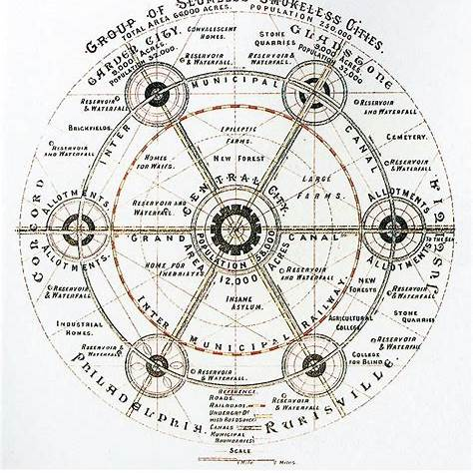
The Garden City concept, introduced by Ebenezer Howard in the late 19th century, aimed to merge the advantages of urban and rural life while mitigating their respective drawbacks. Howard's vision entailed self-contained communities surrounded by greenbelts, integrating residential, industrial, and agricultural zones. This model sought to address the challenges of overcrowded cities and declining rural areas by promoting balanced development.
Figure 1 Model of garden city I

Strengths:
- Integration of Green and Built Environments: Garden Cities exemplify early efforts to integrate nature within urban settings, aligning with life-centric principles of ecological interdependence and habitat connectivity.
- Focus on Community Well-being: The prioritization of communal gardens, public spaces, and walkability fosters social cohesion and opportunities for human-nature interaction key components of ecological justice and sensory/relational urbanism advocated in your research.
- Precedent for Multispecies Infrastructure: By preserving greenbelts and open space, Garden Cities offer the potential for multispecies cohabitation, echoing your framework’s call for urban environments that support both human and more-than-human life.
- Regenerative Potential: The model’s original intent to blend rural and urban land uses foreshadows regenerative planning by maintaining ecosystem services within city boundaries.
Limitations:
- Anthropocentric Focus: While Garden Cities promote access to nature, their design primarily centres on human needs (leisure, aesthetics, health), with limited explicit provisions for non-human species’ habitat needs or multispecies infrastructure.
- Fragmentation Risk: Despite greenbelts, the typical zoning and layout can still result in ecological fragmentation, which your research critiques as detrimental to urban biodiversity and ecosystem functionality.
- Static Green Space: The green infrastructure in traditional Garden Cities often lacks dynamic, place-based ecological strategies (such as wilding or adaptive habitat creation) central to life-centric urbanism.
- Governance and Equity Issues: Historical applications sometimes resulted in social exclusion or did not address broader urban equity; your research calls for democratized access to nature and participatory governance, which is often missing in the classical Garden City approach.
- Commodification of Green Spaces: Modern adaptations risk turning green areas into marketable real estate features rather than relational ecological commons a critique highlighted in your abstract against technocratic green infrastructure.

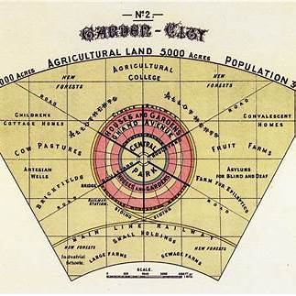
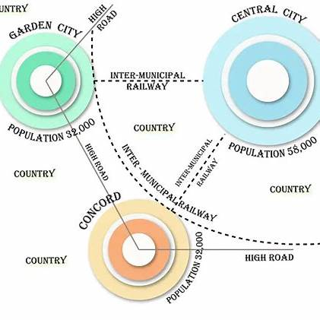

Figure 2 garden city model 2
Figure 3

2.2 Concentric Zone Model
The Concentric Zone Model, developed by sociologist Ernest W. Burgess in 1925, explains urban growth based on spatial and socio-economic organization. Drawing from his study of Chicago, Burgess proposed that cities expand outward in concentric rings from a central business district (CBD). Each zone represents a different function and socio-economic group.
The five zones include:
- Central Business District (Zone I): The urban core with high land value, intense commercial use, and minimal residential presence.
- Zone of Transition (Zone II): Characterized by deteriorating housing, light industry, and often populated by immigrants and low-income groups.
- Working-Class Residential Zone (Zone III): Inhabited by blue-collar workers in modest housing near employment centres.
- Middle-Class Residential Zone (Zone IV): Better quality housing with improved amenities and more open space.
- Commuter Zone (Zone V): Outermost zone with affluent residents who commute into the city from suburban or rural areas.
The model reflects processes like invasion and succession and illustrates social segregation, mobility, and land value dynamics in urban areas.
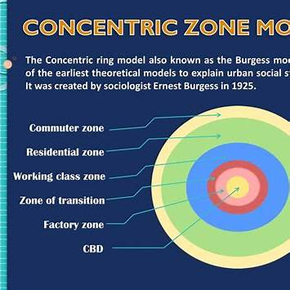
Figure 4 concentric zonal model

Strengths (Based on Life-Centric Urbanism)
- Socio-Spatial Stratification Insight:
The model provides a foundational framework to understand how socio-economic status affects spatial urban development—relevant for designing equitable access to urban resources.
- Urban Evolution Concept:
Invasion and succession echo ecological processes of adaptation and transformation, resonating with dynamic urban ecology emphasized in life-centric planning.
- Analytical Utility:
It enables comparative urban analysis and visualization of zoning conflicts, which can inform planning strategies that aim to restore social and ecological balance.

Limitations (From a Life-Centric Urbanism Lens)
- Anthropocentric Focus:
The model only considers human social and economic dynamics, excluding non-human species and ecological systems that form the core of life-centric urbanism.
- No Ecological Integration:
There is a complete absence of green infrastructure, biodiversity corridors, or ecosystem services—key pillars in life-centric frameworks.
- Static Representation:
Urban systems are shown as fixed and radial. The model does not address the complexity and fluidity of modern ecological, climatic, and multispecies interactions.
- Lack of Cultural and Sensory Dimensions:
Life-centric urbanism highlights emotional, symbolic, and cultural relationships with nature—absent in Burgess’ rational-economic perspective.
- Not Universally Applicable:
Based on Chicago in the early 20th century, the model doesn’t suit informal, dense, or historically layered cities like Delhi. It ignores site-specific ecological histories and socio-environmental contexts crucial to your research at Rajghat.

2.3 Transit-Oriented Development (TOD)
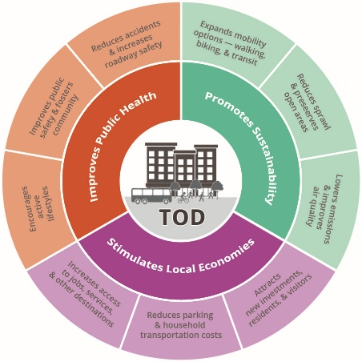
Transit-Oriented Development (TOD) is an urban planning strategy designed to create compact, walkable, and high-density communities cantered around efficient public transportation networks. Its primary goal is to reduce car dependency by making everyday destinations—such as workplaces, markets, and schools—easily accessible by walking, cycling, or transit. TOD is guided by principles like promoting pedestrian and bicycle-friendly streets, encouraging mixed land use, increasing density near transit nodes, and fostering spatial connectivity. The intention is to build neighbourhoods that are sustainable, inclusive, and resource efficient.
Figure 5

Strengths of TOD from a Life-Centric Urbanism Perspective
- Sustainable Mobility and Reduced Emissions
TOD promotes walkability and cycling, and connects people to public transport, leading to lower carbon footprints, improved air quality, and healthier lifestyles—all core outcomes of ecological and regenerative planning.
- Efficient and Compact Urban Form
High-density, mixed-use neighbourhoods near transit reduce the need for extensive land consumption and urban sprawl, preserving outlying ecosystems and farmland—an indirect benefit for non-human habitats.
- Equity-Oriented Accessibility
By concentrating services and infrastructure in easily reachable zones, TOD enhances access for people of different socio-economic backgrounds, including those without private vehicles.
- Potential for Green Integration
Although not a core TOD requirement, the framework allows opportunities for incorporating green roofs, pocket parks, and bio-retention systems that can be adapted to support biodiversity.
Limitations of TOD from a Life-Centric Urbanism Perspective
- Anthropocentric Focus
TOD designs are optimized for human movement and convenience, often overlooking the spatial and ecological requirements of non-human species such as pollinators, birds, or small mammals.
- Ecological Connectivity is Often Neglected
While spatial connectivity is emphasized for humans, ecological corridors and landscape linkages necessary for multispecies movement are typically absent.
- Gentrification and Displacement Risks
As land values increase around transit nodes, low-income and vulnerable populations may be priced out, contradicting TOD’s equity goals and challenging the inclusive ethos of life-centric design.
- Top-Down Implementation
Many TOD projects are designed and implemented with limited community participation, whereas life-centric urbanism calls for deeply participatory, place-based planning that includes both human and ecological stakeholders.

2.4 Smart Cities Mission
Launched in June 2015 by the Government of India, the Smart Cities Mission aims to transform urban areas into more sustainable, inclusive, and citizen-friendly environments. The initiative focuses on enhancing the quality of life through the integration of technology, improved infrastructure, and efficient governance. The mission encompasses 100 cities selected through a competitive process, each tasked with implementing smart solutions to address urban challenges.
Key components of the mission include:
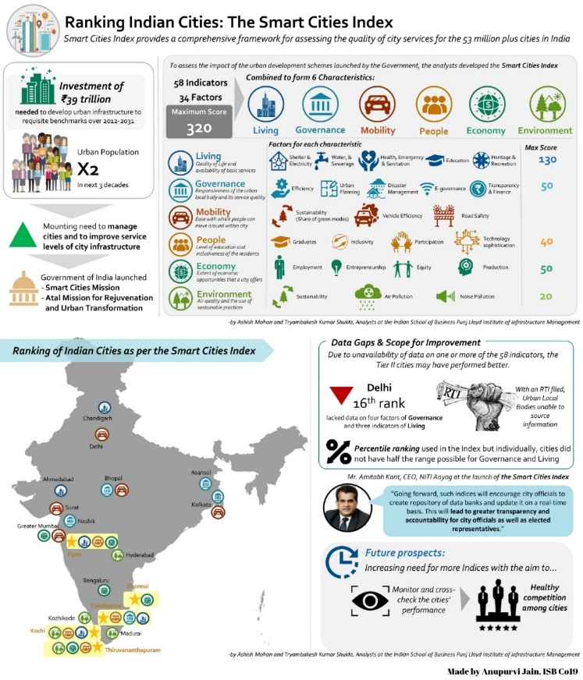
- Core Infrastructure Development: Ensuring adequate water supply, sanitation, affordable housing, and efficient urban mobility.
Figure 6
- Sustainable Environment: Promoting energy efficiency, renewable energy sources, and green spaces.
- Smart Solutions: Leveraging technology for better governance, service delivery, and citizen engagement.
- Area-Based Development: Focusing on retrofitting, redevelopment, and greenfield development to improve existing urban areas.
As of January 2025, significant progress has been made, with numerous projects completed across various cities.
Strengths in Relation to Life-Centric Urbanism
- Integration of Technology for Enhanced Liveability: The mission's emphasis on smart solutions aligns with life-centric urbanism's goal of creating environments that cater to the well-being of all life forms.
- Focus on Sustainable Infrastructure: By promoting energy efficiency and green spaces, the mission supports ecological balance and biodiversity, key aspects of life-centric urbanism.
- Citizen-Centric Approach: The initiative encourages citizen participation in planning and decision-making, fostering a sense of community and shared responsibility.
- Replication Potential: Successful models from the mission can serve as blueprints for other cities, facilitating widespread adoption of sustainable urban practices.
Limitations from a Life-Centric Urbanism Perspective
- Anthropocentric Bias: While the mission focuses on human-centric development, it often overlooks the needs of non-human species, which are integral to a holistic urban ecosystem.
- Limited Emphasis on Biodiversity: The creation and preservation of habitats for various species are not prominently featured, potentially disrupting ecological networks.
- Data Privacy Concerns: The extensive use of surveillance and data collection technologies raises issues related to privacy and autonomy, which can affect the overall quality of life.
- Uneven Implementation: Disparities in resource allocation and administrative capacities among cities can lead to inconsistent outcomes, undermining the mission's objectives.

2.5 Critique: Fragmentation, Inequity, Anthropocentrism
While modern urban planning paradigms have evolved in response to shifting economic, social, and environmental demands, they remain fundamentally limited by three interlinked structural flaws: spatial fragmentation, socio-spatial inequity, and deep-rooted anthropocentrism.
A. Fragmentation: Ecological Disintegration Through Planning
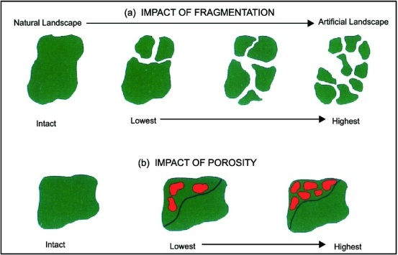
One of the most pervasive outcomes of conventional planning is the physical and ecological fragmentation of urban environments. Zoning-based models such as the Concentric Zone Theory and Garden City principles have institutionalized the compartmentalization of land into rigid functional zones—residential, industrial, commercial, and recreational. While functionally efficient, this spatial segregation has systematically severed ecological flows.
- Wildlife corridors are interrupted by highways and arterial roads.
- Water cycles are broken by impermeable surfaces, leading to urban flooding.
- Tree canopies are replaced with isolated green patches, too fragmented to support biodiversity.
Even Transit-Oriented Development (TOD), despite its sustainability narrative, often reinforces fragmentation by concentrating development in high-value transit zones, inadvertently depleting or displacing nearby ecological systems to make way for densification.
The result is a mosaic of urban islands—disconnected ecologically and socially—unable to sustain systemic resilience. Nature is reduced to discrete objects: a park here, a green roof there, with no larger ecological metabolism in mind.
B. Inequity: Uneven Access to Urban Nature
A second and equally damaging outcome is the socio-spatial inequity baked into planning models. By privileging certain land uses or populations, these paradigms reinforce green privilege—the unequal distribution of ecological assets such as clean air, tree cover, or proximity to biodiverse environments.
Key examples:
  - In TOD frameworks, transit-rich, amenity-heavy zones often become gentrified, pushing low-income residents to less connected, ecologically barren peripheries.
  - In Smart City projects, high-tech green infrastructure (like vertical gardens or sensor-equipped green corridors) is disproportionately concentrated in elite districts, while informal or peripheral neighbourhoods remain under-served.
  - Even Garden City-inspired developments, which emphasize greenery, are often inaccessible to lower-income groups due to land cost inflation or privatized green commons.
UN-Habitat (2020) has highlighted that this spatial bias results in vulnerable populations suffering the brunt of environmental degradation, including urban heat islands, poor air quality, and lack of shade or open space—all of which disproportionately affect mental and physical well-being.
Thus, the current models perpetuate eco-apartheid—a term coined to describe the environmental divide between those who can afford ecological wellness and those who cannot.
C. Anthropocentrism: Nature as Utility, Not Kin
At the conceptual core of all major planning paradigms is an enduring anthropocentric worldview—one that sees humans as the sole subjects of urban development and non-human life as subordinate or decorative.
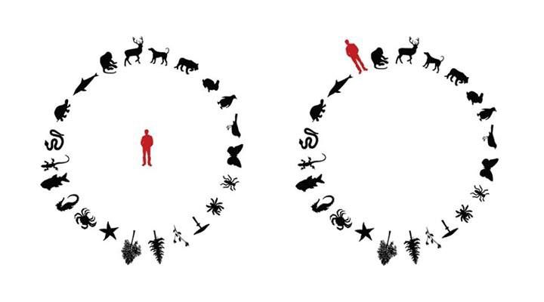
Examples of this mindset:
  - In Garden Cities, green spaces are aesthetic buffers, not living systems.
  - In TOD, ecological features are instrumentalized to increase footfall and land value.
  - In Smart Cities, nature is “optimized” through sensors, often stripped of complexity or autonomy.
Even in contemporary planning movements like Nature-Based Solutions (NBS), nature is rarely treated as a co-planner or cohabitant. Instead, it is reduced to ecosystem services—measured by how well it performs functions like carbon sequestration, air filtration, or stormwater retention for humans.
This instrumental view of nature misses the point of ecological interdependence. It negates nature’s agency, subjectivity, and right to evolve beyond human control. In doing so, it fails to recognize the city as a shared habitat, not a human-centric machine.

2.6 Missed Opportunity: Nature as Passive Background, Not Active Agent
Across the history of urban planning—from the orderly landscapes of Garden Cities to the algorithmic logic of Smart Cities—nature has been consistently positioned as a passive backdrop, an aesthetic feature or a resource to be exploited, rather than an active agent shaping urban life and form. This fundamental framing error is at the heart of why even the most well-meaning “green” cities fail to address ecological degradation and systemic imbalance.
A. Nature as Ornament, Not System
In dominant planning models, nature is typically introduced after the core infrastructure has been laid out as parkland, median trees, rooftop gardens, or green façades. These elements often function more as beautification devices than integral systems of urban life. Their success is judged by visual appeal, recreational use, or carbon offset metrics not by their role in supporting pollination, seed dispersal, animal migration, water cycling, or soil regeneration.
Even in advanced models like Transit-Oriented Development (TOD), green elements are deployed to enhance real estate value or human comfort, not to restore habitat connectivity or microbial diversity. Nature is fragmented and aestheticized often simulated in form (green walls, artificial wetlands) but disconnected in function.
B. Suppressed Agency of Nature
Urban plans rarely consider the agency of rivers, forests, animals, fungi, or seasonal rhythms. Masterplans typically flatten ecological complexity into zoning diagrams and land-use codes, abstracting nature into fixed parcels. Wildness is erased for order. Trees are planted in linear rows; water is piped and canalized; soil is compacted beneath impervious surfaces.
By suppressing nature’s agency, cities become ecologically inert—unable to adapt, regenerate, or host multispecies life. The city becomes something built over nature, rather than with it. This colonial logic assumes that the urban environment is separate from, and superior to, ecological processes—an assumption that is both scientifically inaccurate and ethically untenable in the context of the climate crisis.
C. The Absence of Co-Design with More-than-Humans
Current planning frameworks lack tools or methodologies to meaningfully include non-human life in the design process. Urban trees are selected for low-maintenance qualities, not biodiversity potential. Wetlands are drained for “clean” land. Wildlife crossings are treated as technical fixes rather than indicators of deeper planning failure.
This oversight is not merely technical—it reflects a deep cultural blind spot. Most planning models operate within anthropocentric epistemologies, where cities are designed by and for humans alone. Nature, at best, is a service provider; at worst, an obstacle to be overcome.
D. Implications of this Framing
By treating nature as background instead of foreground, cities:
  - Fail to build resilience to climate extremes (floods, droughts, heatwaves)
  - Lose opportunities for ecological continuity and species cohabitation
  - Miss out on relational wellbeing—the psychological and cultural benefits of multispecies entanglement
  - Contribute to the systematic erasure of indigenous, traditional, and biocentric worldviews, where land and life are seen as kin, not commodities
As a result, even “green” cities end up becoming sterile, extractive, and unlovable in the long run, despite their visual greenness or smart infrastructure.

CHAPTER 3 THEORETICAL FRAMEWORK

3.1 Ecological Urbanism City as Ecosystem

3.1.1 Introduction to Ecological Urbanism
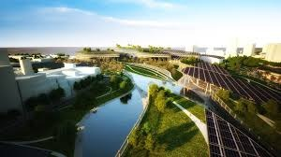
In response to the growing disconnect between urban development and environmental sustainability, Ecological Urbanism has emerged as a vital framework for reimagining the city as a living, evolving ecosystem. Introduced in the seminal work Ecological Urbanism edited by Mohsen Mostafavi and Gareth Doherty (2010), the paradigm advocates for integrating ecological knowledge and design thinking into the urban fabric. This perspective does not treat ecology as an aesthetic layer to be applied superficially, but as a fundamental structuring logic of city-making. Where modernist planning once prioritized zoning, circulation, and infrastructure, ecological urbanism repositions energy flow, biodiversity, adaptation, and interdependence as central urban planning concerns.

3.1.2 Key Principles and Theoretical Foundations
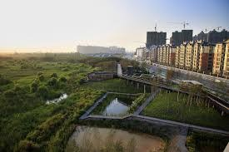
Ecological Urbanism draws heavily from systems theory and environmental science, positioning the city as a complex adaptive system. It sees urban landscapes not as static objects but as dynamic environments that change over time—driven by both human activity and natural processes. Its core principles include hybridization (blending infrastructure with landscape), resilience (the ability to adapt and recover), and successional thinking (embracing time, decay, and renewal as part o f design). Importantly, the framework also promotes coexistence, acknowledging that urban space is shared among multiple species, not solely designed for human habitation.
The emphasis on process over product marks a shift in urban thinking—from fixed masterplans to open-ended, evolving urban ecologies. This aligns with ecological principles such as diversity, redundancy, and nested hierarchies. In this view, urbanism is not separate from nature but a manifestation of it, subject to the same metabolic, climatic, and geological forces that govern natural systems.

3.1.3 Contributions to Life-Centric Urbanism
The ecological urbanism framework provides a strong foundation for Life-Centric Urbanism by offering a vocabulary and logic for embedding life systems within city form. It contributes several key insights:
- First, it legitimizes the idea that cities are ecosystems, not engineering projects. This concept allows planners to move beyond static land-use maps and toward fluid, responsive environments.
- Second, it validates the integration of ecological succession and natural disturbances into planning—acknowledging floods, wild growth, decay, and species migration as integral design events.
- Third, it supports multifunctional landscapes where streets, parks, rooftops, and walls perform ecological roles: purifying air, retaining water, sequestering carbon, or offering habitat.
Life-Centric Urbanism builds upon this by formalizing these ideas into measurable criteria, such as those proposed in the Life-Centric Urbanism Index (LCUI), which quantifies ecosystem continuity, carbon cycles, soil health, and biodiversity density.

3.1.4 Exemplary Case Studies and Projects
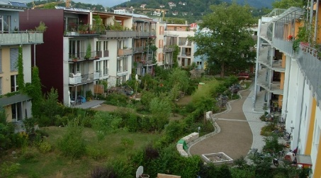
Several real-world projects embody the principles of ecological urbanism and provide precedent for its application:
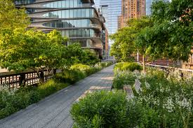
- Vauban (Freiburg, Germany) exemplifies an eco-district where land-use, mobility, and architecture are all integrated into a human-nature system. Car-free zones, green roofs, energy-efficient housing, and public orchards create a community embedded in ecological values.
- The High Line (New York City) transforms obsolete infrastructure into a biodiverse public corridor. The project incorporates native plantings, passive microclimate regulation, and bird habitats within a pedestrian experience.
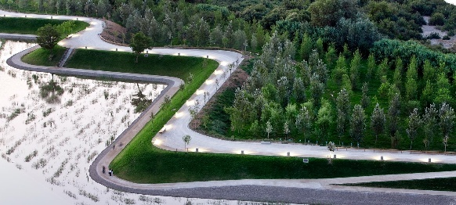
- Zaragoza Water Park (Spain) demonstrates the potential of landscape to simultaneously serve recreational, ecological, and hydrological functions —merging flood management with community life and biodiversity.
These examples reveal the multifunctionality and temporal resilience possible when cities are designed with ecosystems in mind.

3.1.5 Limitations and Critique
Despite its strengths, Ecological Urbanism has not yet achieved widespread systemic transformation. One limitation is its tendency to remain within the disciplinary bounds of architecture and landscape, lacking traction in urban governance or institutional planning codes. Often, its most celebrated applications are boutique projects or design showcases, limited to affluent or gentrified zones.
Moreover, while it gestures toward ecological ethics, Ecological Urbanism tends to underemphasize socio-political dimensions, such as environmental justice, indigenous knowledge systems, or the rights of non-human beings. Its treatment of nature remains largely functional and anthropocentric—valued for ecosystem services or urban cooling rather than as life with its own agency. As a result, ecological urbanism risks aestheticizing nature without addressing its embedded hierarchies or long-term vulnerability to commodification and control.

3.1.6 Toward Life-Centric Integration
Life-Centric Urbanism advances the ambitions of Ecological Urbanism by transforming its theoretical depth into policy-ready frameworks and ecologically accountable metrics. It responds to the need for:
- Scalability: Going beyond exemplary districts to entire city systems.
- Multispecies justice: Centering the well-being and rights of flora, fauna, and microbial life alongside human welfare.
- Systems literacy: Mandating ecological literacy and performance in planning institutions, from land-use codes to building regulations.
In Life-Centric Urbanism, nature is not treated merely as an environment to be protected or simulated—it is a co-designer of space, time, and value in the city. The shift is from “green space” to “living space,” from “land-use” to “life-use,” from passive integration to active collaboration with life systems.

3.2 Biophilic Urbanism – Multisensory, Health-Enhancing Design

3.2.1 Introduction to Biophilic Urbanism
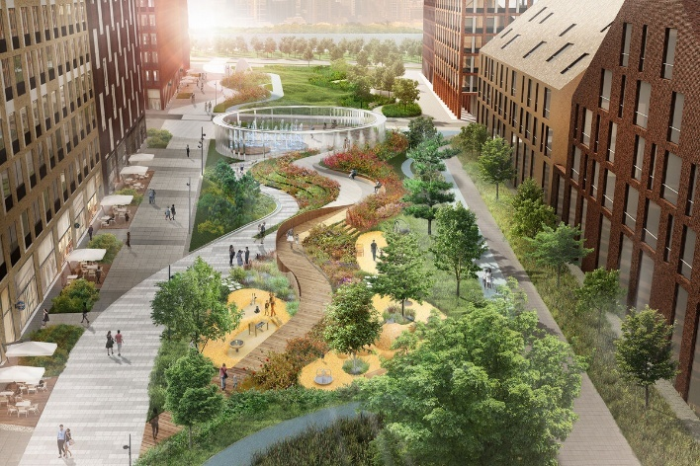
Biophilic urbanism emerges from the biophilia hypothesis, which suggests that humans possess an inherent biological need to connect with nature. First introduced by psychoanalyst Erich Fromm and later popularized by biologist E.O. Wilson, biophilia frames nature not as a luxury but as a fundamental component of human health, development, and wellbeing. In the context of urban design, biophilic urbanism translates this hypothesis into practice by integrating natural systems, forms, and experiences into the built environment. It aims to restore the human-nature relationship eroded by industrialization, urban sprawl, and the dominance of me chanistic planning models.
Unlike ecological urbanism, which often emphasizes macro-systems like hydrology or vegetation cover, biophilic urbanism focuses on sensory experience and emotional engagement. It operates primarily at the scale of daily life: streets, interiors, facades, parks, and walkways. The goal is not only to bring nature into the city but to make it experiential, participatory, and nourishing, enhancing mental and physical health through design.

3.2.2 Principles and Design Strategies
Stephen Kellert and Elizabeth Calabrese have proposed a detailed framework for biophilic design, structured into three primary domains: direct experience of nature, indirect experience of nature, and the experience of space and place. These domains encompass elements such as natural light, vegetation, flowing water, tactile surfaces, biomorphic patterns, and spatial configurations that promote psychological comfort.
Agata Cabanek et al. (2020) further extend this framework to streetscapes, proposing the Biophilic Streets Design Framework, which incorporates nature into six key functions: traffic planning, energy management, stormwater retention, biodiversity enhancement, street furniture, and environmental education. These strategies demonstrate that biophilic urbanism can serve not only aesthetic and emotional needs but also performative and ecological functions, such as cooling, habitat creation, and air purification.
In practice, biophilic design may include green walls, permeable pavements, butterfly gardens, moss-covered bus shelters, or interactive water features. These interventions are often small in scale but large in impact, transforming urban environments from inert surfaces into dynamic, healing landscapes.

3.2.3 Empirical Benefits and Global Practices
An expanding body of empirical research supports the claim that biophilic environments positively affect human physiology and cognition. Studies have shown that offices with natural daylight and views can boost productivity by up to 12%, reduce sick leave, and improve mood. In educational settings, biophilic features have been linked to better attention spans, higher retention, and improved academic performance. In hospitals, patients recover faster in rooms with natural views, requiring fewer painkillers and demonstrating lower stress levels.
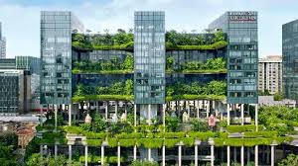
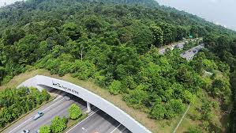
Urban-scale interventions also reveal promising outcomes. Cities like S ingapore, with its iconic Parkro yal on Pickering and the Eco-Link@BKE wildlife overpass, have institutionalized biophilic design as urban policy. Melbourne and Portland have retrofitted green infrastructure into their transit systems and laneways, creating everyday access to nature in dense urban environments. These examples affirm that biophilic urbanism is scalable and versatile, adaptable to diverse climates, cultures, and budgets.

3.2.4 Critique and Limitations
Despite its merits, biophilic urbanism is not without critique. One major limitation is its overemphasis on human benefit, often reproducing anthropocentric assumptions that see nature only as a tool for human wellness. This instrumental view reduces ecosystems to “services” and risks green gentrification, where biophilic improvements drive up property values and displace vulnerable communities.
Moreover, many biophilic interventions remain superficial or tokenistic—adding potted plants or green veneers without addressing underlying ecological dysfunctions. As Oliveira (2025) argues, biophilic design often lacks systemic thinking, failing to integrate with broader infrastructures like waste loops, soil cycles, or watershed health. When deployed without regulation, biophilic elements can become privatized luxuries, accessible only to the affluent, rather than equitable environmental rights.

3.2.5 From Biophilia to Multispecies Urbanism
Life-Centric Urbanism builds on the foundations of biophilic urbanism but extends its ethical horizon. It shifts the focus from designing nature for human comfort to designing urban systems where nature itself thrives, recognizing animals, plants, fungi, and even microbes as urban citizens with spatial, nutritional, and sensory needs.
This multispecies perspective encourages the inclusion of nesting niches in architecture, wildlife corridors embedded in road design, and pollinator-friendly plant palettes in public spaces. It also calls for equitable biophilic access, ensuring that low-income and marginalized communities benefit equally from multisensory, biodiverse environments. In this sense, biophilic design becomes not just a healing practice for humans but a framework of interspecies reciprocity and care.

3.3 Nature-Based Solutions (NBS) – Critique of Vague “Nature”

3.3.1 Introduction to Nature-Based Solutions
Nature-Based Solutions (NBS) have gained significant traction in global urban planning discourse, particularly after their endorsement by the European Commission and international bodies such as the IUCN and the UN Environment Assembly. Broadly defined, NBS are strategies that leverage natural systems—or mimic them—to address urban challenges such as flooding, air pollution, biodiversity loss, and social inequity. They include interventions like constructed wetlands, green roofs, bioswales, and reforestation, designed to deliver simultaneous environmental, social, and economic benefits.
NBS were initially introduced to integrate ecological thinking into climate adaptation and disaster mitigation. Over time, they have become central to the sustainability agendas of municipalities worldwide. However, while NBS offer a promising framework for integrating ecology and infrastructure, they are also limited by conceptual vagueness, particularly in their treatment of the term “nature.” As Lemes de Oliveira (2025) critically asserts, the effectiveness and justice of NBS hinge on how nature is defined, valued, and operationalized.

3.3.2 The Four Natures of NBS
A major insight from contemporary scholarship on NBS is that “nature” is not a neutral or universally agreed-upon category. Drawing on Oliveira’s analysis, NBS literature demonstrates four dominant conceptualizations of nature:
  - Wilderness Nature – nature as untouched or pristine, often evoked in rewilding projects.
  - Nature as Resource Provider – ecosystems valued for their services to humans (e.g., carbon capture, cooling, flood absorption).
  - Human-Inclusive Nature – ecosystems understood as entangled with humans, culture, and the built environment.
  - Techno nature or Synthetic Nature – human-made or heavily modified ecosystems designed to simulate natural functions.

Each of these definitions carries distinct planning implications. For example, treating nature as wilderness may inspire conservation corridors but can marginalize local communities through exclusionary zoning. On the other hand, framing nature as a programmable system encourages innovation but risks greenwashing—where ecological vocabulary is co-opted without meaningful performance.

3.3.3 Instrumentalism and Anthropocentrism in NBS
One of the central critiques of NBS is their overwhelmingly instrumental framing. Nature is primarily cast as a solution-provider for human-defined problems: it must clean air, reduce heat, manage water, or enhance real estate value. This reinforces an anthropocentric paradigm, where non-human entities are considered valuable only if they serve human ends.
For instance, green infrastructure is often justified through ecosystem services valuation—assigning monetary worth to pollination, shade, or stormwater retention. While this approach makes nature “legible” to economists and policymakers, it also risks commodifying ecosystems, reducing complex life forms into units of productivity.
Furthermore, this logic ignores intrinsic and relational values of nature—those based on coexistence, cultural identity, spiritual meaning, or multispecies reciprocity. As a result, NBS may deliver technical success (e.g., flood mitigation) while reproducing ethical and ecological failure (e.g., habitat fragmentation, species displacement).

3.3.4 Challenges in Localizing and Contextualizing Nature
Another major limitation in NBS practice is the lack of sensitivity to cultural and ecological context. Global toolkits for NBS often assume a one-size-fits-all definition of “green” or “natural.” However, as Oliveira emphasizes, “nature” is deeply place-based: it carries different meanings across geographies, worldviews, and knowledge systems.
In some urban areas, rewilding may be celebrated; in others, it may be perceived as disorder, risk, or neglect. For indigenous communities, nature may be sacred and animate—not a system to be engineered. Ignoring these nuances leads to top-down interventions that erode local knowledge, violate customary land rights, and overlook more sustainable traditional practices.
Moreover, the failure to include nonhuman perspectives in NBS design—such as species-specific nesting needs, migration patterns, or water dependencies—limits their ecological effectiveness. This reflects a conceptual tension between the technical ambitions of NBS and the relational realities of ecology.

3.3.5 Governance and Equity Concerns
NBS are often implemented in ways that reinforce existing inequalities. For example, green infrastructure projects can trigger eco-gentrification, raising property values and displacing vulnerable populations. In other cases, NBS funds are disproportionately directed toward already-wealthy neighbourhoods, where political capital is stronger and land is more “valuable.”

Equally problematic is the lack of participatory governance in many NBS initiatives. While these projects are framed as “solutions,” they are rarely co-created with affected communities, leading to alienation or resistance. Without robust frameworks for ecological democracy—where humans and more-than-humans are represented—NBS risk becoming a new form of green authoritarianism.

3.3.6 From Nature-Based to Life-Centric
Life-Centric Urbanism critically engages with NBS but reorients it toward post-anthropocentric values. It asks not what nature can do for the city, but what the city can do to restore, protect, and co-evolve with life systems. It retains the functionality of NBS but reframes them through three key lenses:
- Plural definitions of nature that embrace wilderness, hybridity, and more-than-human agency.
- Relational values that centre multispecies wellbeing and cohabitation, not just human benefit.
- Local and ecological specificity, where the form and function of each intervention arise from contextual listening—not imported standards.
Through the Life-Centric Urbanism Index (LCUI), such reframing becomes measurable. It includes indicators for species richness, native planting, habitat connectivity, and more-than-human infrastructure, ensuring that urban nature is not symbolic or exploitative, but living, active, and valued.

3.4 Posthumanism & Relational Design – Multispecies Ethics, Co-Evolution

3.4.1 Introduction: Beyond the Human-Centred City
Contemporary urbanism is largely rooted in anthropocentric ideologies—models where the human is both the subject and measure of planning. In such systems, cities are designed primarily to meet human needs, with non-human lifeforms relegated to passive background elements or abstracted into services. In contrast, post humanist urban theory challenges this human-exceptionalism and invites planners to consider cities as multispecies assemblages—shared habitats where humans, animals, plants, fungi, microbes, and technologies co-shape urban life.
Posthumanism is not anti-human, but rather decentres the human to reframe our role as participants in broader ecological and ethical systems. When applied to urbanism, this perspective compels a fundamental rethinking of design, planning, and governance. It introduces relational ontologies, where identities and responsibilities are not fixed, but co-emerge through networks of mutual dependence. This philosophical shift forms the ethical backbone of Life-Centric Urbanism, which insists that flourishing must be shared and systemic, not isolated or competitive.

3.4.2 Multispecies Urbanism and Shared Agency
Drawing from scholars like Donna Haraway, Anna Tsing, and Eben Kirksey, multispecies urbanism recognizes cities as ecosystems in which many forms of life produce, shape, and negotiate space. Sidewalks, street trees, drainage systems, and rooftops are not only human infrastructure—they are also corridors, perches, nurseries, and hunting grounds for a multitude of species.
In this framework, agency is distributed. A pigeon nesting in a traffic light, a fungus decomposing concrete, or a crow reusing wires for its nest—all participate in the urban metabolism. Posthuman urbanism proposes that we move from “cities for people” to “cities with life”—where the rights, rhythms, and intelligences of non-human species are acknowledged in design.
This perspective expands design goals beyond human comfort or efficiency. It asks: Can a bridge be built with wind corridors for bats? Can a housing block include bird-baths, pollinator patches, and soil membranes? Can flood infrastructure double as amphibian breeding grounds? Such questions exemplify a co-design ethic that treats non-humans not as constraints but as contributors.

3.4.3 Relational Design Thinking: From Objects to Networks
Relational design challenges the modernist obsession with form, object, and function by proposing that space is constituted through relationships—not just physical but ecological, temporal, and affective. A park is not merely a void filled with grass and benches; it is a network of pollinators, children, soil microbes, microbial volatiles, smells, seasonal rhythms, and memories.
In relational design, the focus shifts from what a space is to what it enables, sustains, and interconnects. This mode of thinking transforms the act of planning into an act of care and stewardship—an ongoing choreography between species, flows, and materials. It aligns closely with indigenous and non-Western worldviews, where land and life are entangled and non-human beings are treated as kin, not objects.
In practice, relational design translates into ecological layering, temporal flexibility, and adaptive feedback loops. It resists masterplans in favor of iterative systems that evolve based on interaction and learning. This approach is vital for Life-Centric Urbanism, which rejects the rigidity of traditional zoning and embraces the living city as a site of experimentation and co-creation.

3.4.4 Ethics of More-Than-Human Inclusion
Urban planning has long excluded non-human life from legal, ethical, and institutional consideration. Yet, cities profoundly affect the life chances of other species—through habitat loss, pollution, light and sound disruption, and chemical exposure. A relational ethic demands that planners begin to recognize urban species as moral subjects, deserving not only of protection but participation in shaping their environments.
This aligns with the growing field of multispecies justice, which asserts that equity must extend beyond the human community. Legal movements such as the “Rights of Nature” and ecological personhood—already recognized in places like New Zealand, Ecuador, and India—provide powerful precedents for imagining more inclusive urban governance. A Life-Centric Policy Framework would include biodiversity impact assessments, multispecies zoning overlays, and co-habitation metrics embedded into city plans.
Such ethics also require rethinking infrastructure. Roads, for example, are among the most lethal artifacts for wildlife. A life-centric approach would mandate permeable mobility networks, designed with crossings, tunnels, and vegetated verges for animal movement. Buildings would be evaluated not just on human occupancy but on their ability to host and support ecological life.

3.4.5 From Control to Co-Evolution
Modern planning has often treated nature as something to be managed, optimized, or restrained—through flood walls, pest control, or landscape maintenance. But relational and post humanist thinking reframes nature not as chaotic or threatening, but as a co-evolving partner. This approach urges planners to design with disturbance, unpredictability, and resilience in mind.
For example, rather than preventing floods, a relational city would design for water’s behaviour—creating retention landscapes, seasonal wetlands, or amphibious architecture. Instead of sterilizing soil, it would encourage fungal networks and microbial health. Instead of monoculture trees, it would plant mixed, locally-adapted species that co-evolve with climate and culture. In short, cities become gardens of complexity, not temples of control.
Life-Centric Urbanism borrows from this ethos of living-with rather than mastering-over. It proposes cities that regenerate, respond, and adapt—not through command systems but through ecological intelligence and multispecies coordination.

3.4.6 Conclusion: Posthumanism as a Framework for Ethical Urban
Futures Posthumanism and relational design offer a transformative lens for urban theory, planning, and practice. They allow us to move beyond shallow sustainability and toward deep, empathetic coexistence. Life-Centric Urbanism is both enabled and elevated by these philosophies: it is not just about adding green or preserving life, but about reconfiguring the ethical basis of urbanism itself.
In this model, the city is no longer a machine, a container, or a smart interface—it is a living field of relationships, pulsing with interdependence. By embracing multispecies ethics and relational infrastructure, Life-Centric Urbanism cultivates a future where cities do not just accommodate life but are animated by it.

CHAPTER 4 SINGAPORE CASE STUDY: INTEGRATING GREEN INFRASTRUCTURE AND BIODIVERSITY

4.1 Introduction
Singapore, a densely populated city-state, has emerged as a global leader in urban sustainability by embedding nature into its urban fabric. Through strategic planning and innovative design, Singapore has transformed itself into a "City in Nature," emphasizing ecological connectivity, biodiversity conservation, and sustainable living

4.2 Eco-Link@BKE: A Model for Ecological Connectivity
The Eco-Link@BKE is a 75-meter-long ecological bridge that reconnects the Bukit Timah Nature Reserve and the Central Catchment Nature Reserve, which were previously divided by the Bukit Timah Expressway. Since its completion in 2013, the bridge has facilitated safe passage for various wildlife species, including the critically endangered Sunda pangolin, thereby enhancing genetic diversity and reducing roadkill incidents.(Wikipedia, Reuters)
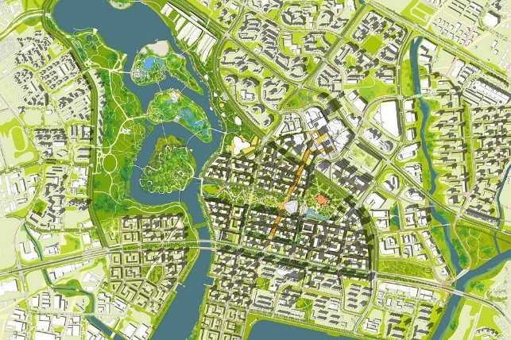
Visual Representation:
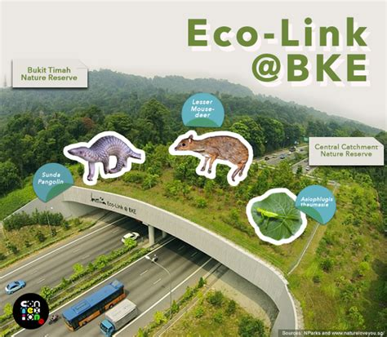
Figure 7
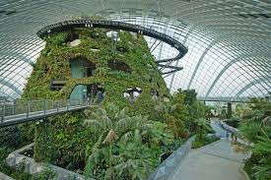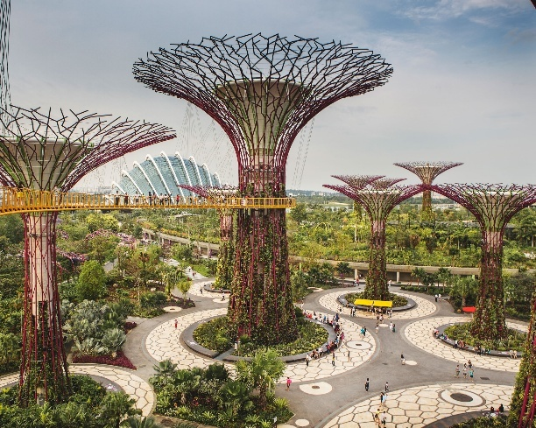

4.3 Gardens by the Bay: Urban Biodiversity and Public Engagement
Gardens by the Bay is a 105-hectare urban park that showcases Singapore's commitment to integrating biodiversity within urban spaces. Featuring the iconic Supertree Grove and climate-controlled conservatories, the park serves as a habitat for diverse plant species and provides educational and recreational opportunities for the public.(The Times)
Visual Representation:

4.4 Bishan-Ang Mo Kio Park: River Naturalization and Community Spaces
The transformation of Bishan-Ang Mo Kio Park involved the naturalization of a concrete canal into a meandering river, enhancing flood resilience and creating a vibrant ecosystem within the urban environment. This project exemplifies the integration of water-sensitive urban design and community-centric green spaces.(Wikipedia)
Visual Representation:

4.5 Alignment with LCUI Indicators
Singapore's initiatives align with several LCUI indicators:
- Ecological Continuity (EC1 & EC2): The development of green corridors like Eco-Link@BKE enhances habitat connectivity.
- Multispecies Infrastructure (MS1 & MS4): Designing urban spaces that cater to various species supports biodiversity.(Xisdxjxsu)
- Regenerative Systems (EF3): Projects like Bishan-Ang Mo Kio Park demonstrate effective water management and ecosystem restoration.(Oxford Academic)
- Human–Nature Relationships (HN1 & HN3): Gardens by the Bay fosters public engagement and environmental education.(The Times)
- Governance & Ethics (PG1): Singapore's policies and planning frameworks institutionalize ecological considerations.
Conclusion
Singapore's approach to urban planning serves as a benchmark for integrating ecological principles into city development. By prioritizing biodiversity, ecological connectivity, and community engagement, Singapore exemplifies the practical application of Life-Centric Urbanism, offering valuable insights for cities worldwide aiming to harmonize urban growth with environmental stewardship.
Note: The images provided are for illustrative purposes to enhance understanding of Singapore's green infrastructure initiatives.

CHAPTER 5 CRITIQUE OF CURRENT FRAMEWORKS

5.1 Nature as a Service: A Problem of Value Framing
A prevailing flaw in dominant planning frameworks—from Sustainable Development to Nature-Based Solutions (NBS)—is their reduction of nature to a set of “services” rendered for human benefit. This instrumentalist view, widely propagated through ecosystem services literature and policies, treats nature as a toolbox for urban resilience: it must purify air, manage stormwater, cool streets, or enhance productivity. While this framing has enabled ecological concerns to enter mainstream urban discourse, it comes at a profound cost—it erases intrinsic, relational, and plural values of nature.
The IPBES (2022) conceptual framework recognizes three primary ways people value nature: instrumental, intrinsic, and relational. Instrumental values focus on utility; intrinsic values affirm the right of nature to exist, flourish, and evolve independently of human use; relational values acknowledge nature as part of collective identity, memory, and responsibility. Current frameworks overwhelmingly emphasize the first, often to the exclusion or tokenization of the others.
Oliveira (2025) critiques this approach by warning that when nature is viewed only through its functional benefit to humans, it becomes easy to commodify and sacrifice when economic pressures rise. Wetlands become flood retention basins. Trees become heat mitigation devices. Diversity becomes a numerical performance target. This logic sustains a superficial greening of cities without addressing ecological ethics, regeneration, or long-term resilience.

5.2 Greenwashing through Nature-Based Solutions
As urban design has adopted the vocabulary of sustainability, many planning models have embraced NBS as a catch-all solution. However, NBS often serve as a veneer—aesthetic or technical additions that do not challenge the underlying extractive structures of the urban economy. A green wall on a corporate tower or a bioswale on a luxury boulevard may meet policy checkboxes, yet fail to support biodiversity, ecosystem connectivity, or community inclusion.
This superficial deployment is what critics term greenwashing—the co-opting of ecological language and visuals for reputational or financial gain. According to Oliveira (2025), NBS often operate within grey-box constraints: designed by engineers, implemented without local consultation, and evaluated for visual or economic ROI rather than ecological richness or social benefit. They frequently rely on ambiguous terms like “green infrastructure” or “resilient systems” without defining what kind of nature is involved, or for whom it is designed.
Moreover, many NBS interventions favor high-tech, controlled, and human-engineered nature. For example, vertical gardens maintained through automated irrigation systems with non-native species may serve branding purposes but lack meaningful ecological integration. This kind of “decorative ecology” fails to replicate the messiness, seasonality, and multispecies interaction that characterize true ecological function.

5.3 Absence of Multispecies Rights and Stewardship Policies
Perhaps the most critical limitation of current planning models is their failure to include non-human life as stakeholders. Despite increasing awareness of biodiversity loss, urban policies rarely enshrine the rights of species, ecosystems, or natural cycles. Planning codes remain anthropocentric, regulating land use for human productivity, mobility, and safety, while neglecting nesting needs, migratory flows, or habitat continuity.
There is no institutional mechanism for representation of animals, plants, fungi, or soil systems in most urban decision-making. Wildlife corridors, when they exist, are often fragmentary and secondary. Animal movement is treated as a disruption to traffic. Vegetation is managed for human aesthetics, not ecosystem resilience. In the absence of multispecies governance, cities continue to grow as mono-species machines—optimized for speed, control, and capital, but hostile to diversity and coexistence.
Additionally, stewardship models are rare and underfunded. While some cities support community gardens or biodiversity awareness programs, these are often limited in scale and disconnected from infrastructure, housing, and policy planning. Without institutionalizing community ecological responsibility—through stewardship zones, co-managed habitats, or ecological citizenship programs—sustainability remains performative.

5.4 Flattening Complexity: Geometry without Ecology-
Another critique comes from thinkers like Nikos Salingaros, who argue that modern urban geometries lack the mathematical properties found in living systems. Contemporary cities often prioritize formal purity—grids, blocks, smooth surfaces—over the fractal complexity and layered rhythms that support ecological life and human comfort.
Biophilic geometries—curved forms, patterned textures, varied scales—are not merely aesthetic. They resonate with human sensory evolution and support ecological layering. Yet, current frameworks tend to flatten complexity in favor of clean visuals and efficient circulation. This erasure of formal richness mirrors the erasure of ecological and relational complexity: just as biodiversity is reduced to green color, urban form is reduced to lines and pixels.
Planning models that do not engage with the geometry of life—in soils, microbes, roots, weather, rhythms—risk alienating the very systems they claim to support.

5.5 Toward a Life-Centric Reorientation
These critiques underscore the urgency of moving beyond the current paradigms. Life-Centric Urbanism addresses these gaps by proposing a framework that:
- Recognizes intrinsic and relational values of nature alongside ecosystem services
- Embeds ecological performance and multispecies access as urban planning mandates
- Institutionalizes more-than-human representation in planning processes
- Measures success through biological, social, and relational indicators—not aesthetics alone

CHAPTER 6 THE LIFE-CENTRIC URBANISM FRAMEWORK
The Life-Centric Urbanism Index (LCUI) proposes a measurable and ethical reorientation of urban development around the principle of life—not merely human life, but the broader web of interdependent species, systems, and regenerative cycles. In contrast to traditional sustainability frameworks that emphasize efficiency, resilience, or technological optimization, LCUI centers on cohabitation, ecological accountability, and relational equity across species and systems. This section presents the conceptual framework and operational structure of LCUI as a foundational layer for policy, governance, and future research in urban ecology.

6.1 Guiding Principles: Empathy, Continuity, Cohabitation, Feedback
At the heart of LCUI are four non-negotiable principles that reframe how cities are assessed, governed, and lived in.
Empathy
Empathy is not sentimentalism but an epistemological shift—a recognition that urban development must be sensitive to the emotional, biological, and existential well-being of all life forms. It calls for an urban paradigm grounded in interspecies ethics, where design and policy decisions are informed by the needs of those without political voice: animals, plants, microbes, and future generations.
Ecological Continuity
LCUI rejects the fragmentary nature of conventional planning. Instead, it advocates for restored and protected ecological networks across vertical, horizontal, and subterranean dimensions. Continuity ensures that water, soil, and species flows are uninterrupted and integrated into the metabolic functioning of cities.
Cohabitation
More than inclusion, cohabitation asserts that humans must share urban space with other species—not just tolerate them. It implies infrastructure that serves both humans and more-than-human dwellers. Streets, buildings, drainage systems, and rooftops are evaluated by their capacity to support diverse urban ecologies.
Feedback
Inspired by systems ecology, LCUI adopts an adaptive management approach. Urban success is no longer measured by static outcomes but by a city’s ability to sense, learn, and respond—biologically, institutionally, and socially. Feedback loops are institutionalized through ecological monitoring and participatory governance.

6.2 Five Structural Pillars of the LCUI
Each of LCUI’s five pillars is supported by measurable indicators—establishing a performance-based framework for evaluating and improving urban environments across disciplines and governance levels.

6.2.1 Ecological Continuity
This pillar measures how well urban systems preserve, reconnect, and enhance ecological flows. Indicators include:
- EC1: % of connected green cover
- Target: >70% connectivity across vegetation patches using canopies, strips, and forest corridors
- EC2: Length of blue-green corridors per 1000 hectares
- Target: >2 km/1000 ha
- EC3: Habitat fragmentation score
- Target: <10 on a fragmentation index based on patch size and isolation
- EC4: Protected ecological zones
- Target: >10% of total urban land
- EC5: Native species presence
- Target: Baseline documentation and consistent year-on-year increase
This pillar is foundational to systemic health and biodiversity retention in urban zones.

6.2.2 Multispecies Infrastructure
This pillar emphasizes design interventions that make infrastructure usable and beneficial to non-human species. Indicators include:
- MS1: Nesting/shelter integration
- Target: ≥10 biodiversity elements/km² (e.g., bird boxes, burrows, myco-zones)
- MS2: Wildlife crossings
- Target: ≥1 per 5 km of road or barrier infrastructure
- MS3: Pollinator gardens or corridors
- Target: >30% of all landscaped parkland
- MS4: Species-at-risk support features
- Target: Coverage of all locally critical species
- MS5: Biodiversity-sensitive lighting/zoning
- Target: 100% eco-zone compliance
This pillar redefines infrastructure not by utility alone, but by its capacity for ecological hospitality.

6.2.3 Regenerative Systems
LCUI promotes regenerative urban metabolism—where cities not only minimize harm but actively renew ecological resources. Indicators include:
- EF1: % of permeable surface area
- Target: >35% of total urban land
- EF2: Urban agriculture and edible landscapes
- Target: >5 m²/person
- EF3: Rainwater retention
- Target: >25% of total annual rainfall
- EF4: Carbon sequestration capacity
- Target: Locally adjusted baseline based on vegetation and soil data
- EF5: Soil organic health
- Target: >50% soil health threshold across monitored plots
Regenerative metrics enable cities to be ecologically productive, not just sustainable.

6.2.4 Human–Nature Relationships
- This pillar ensures relational equity and ecological literacy among humans—so that access to nature is both universal and meaningful. Indicators include:
- HN1: Proximity to biodiverse greenspace
- Target: >90% of residents within 300m
- HN2: Inclusive green infrastructure
- Target: >75% of public green space with universal/multisensory access
- HN3: Environmental literacy programs
- Target: ≥2 city-wide campaigns per year + school-based curriculum
- HN4: Community stewardship zones
- Target: >10% of green area under co-managed care
- HN5: Perceived well-being from nature
- Target: Positive trend in city-wide ecological wellness surveys
This pillar emphasizes that ecological access is a public right, not a luxury.

6.2.5 Governance & Ethics
This final pillar measures institutional commitment to life-centric metrics. Indicators include:
- PG1: Ecological zoning laws enforced
- Target: >20% of total city area
- PG2: Urban Biodiversity Impact Assessments (UBIA)
- Target: Required for 100% of large-scale developments
- PG3: Green + multispecies design codes
- Target: >70% compliance across public and private sector
- PG4: Urban Ecology Unit
- Target: Fully funded office within city planning departments
- PG5: Resilience and biodiversity KPIs
- Target: Annual publication and public dashboard
Governance mechanisms anchor the LCUI within institutional frameworks, ensuring long-term integration.

A. Ecological Continuity
Indicator | LCUI Code | Standard/Norm Backing | Case Study
Connected green cover | EC1 | NBC 2016: recommends 15–33% minimum green space; Singapore URA: Skyrise greenery index | Singapore: Park Connector Network (PCN), linking 300+ km of green paths
Blue-green corridors | EC2 | CPCB (India): Urban River Management Guidelines; UN-Habitat: Urban Blue-Green Infrastructure Toolkit | Vitoria-Gasteiz, Spain: Urban Green Belt & wetland reconnection
Habitat fragmentation score | EC3 | IPBES, IUCN: Landscape fragmentation metrics | Eco-Link@BKE (Singapore): reduces faunal isolation
Protected ecological zones | EC4 | Eco-Sensitive Zones by MoEFCC (India); Ramsar Criteria | Aarey Forest, Mumbai (proposed ESZ)
Native species presence | EC5 | Biodiversity Act (India): Local Biodiversity Registers (LBRs); GRIHA: Native plant species credit | Bangalore Biodiversity Park: tracks regional flora/fauna
Table 1

B. Multispecies Infrastructure
Indicator | LCUI Code | Standard/Norm Backing | Case Study
Nesting/shelter integration | MS1 | Singapore NParks: Bird-safe design guides; GRIHA: Faunal habitat credits | Vauban, Freiburg: Bat shelters integrated into façades
Wildlife crossings | MS2 | Wildlife Institute of India: Guidelines for animal crossings (MoEFCC, 2016) | NH-44 (Nagpur): Wildlife overpass, tiger movement facilitation
Pollinator corridors | MS3 | FAO Pollinator-Friendly Guidelines; UK Biodiversity Action Plans | Bristol, UK: Pollinator Pathways Network
At-risk species support | MS4 | Wildlife Protection Act, 1972 (India): Schedule I habitat protection | Singapore: Sunda pangolin habitat measures along Eco-Link
Lighting/zoning for biodiversity | MS5 | International Dark Sky Association standards; Singapore URA: Light pollution zoning | Isle of Portland, UK: Dark corridors for bats
Table 2

C. Regenerative Systems
Indicator | LCUI Code | Standard/Norm Backing | Case Study
Permeable surfaces | EF1 | NBC 2016: 30% permeability in site planning; LEED: Credit for stormwater design | Portland, USA: Green Streets Initiative
Edible landscapes | EF2 | MoHUA Advisory: Urban farming on rooftops; GRIHA: Urban agriculture credit | Pune: Yerwada community permaculture projects
Rainwater retention | EF3 | NBC 2016, CPHEEO Manual: Mandatory RWH provisions; LEED/GRIHA: Rainwater credits | Bishan-AMK Park (Singapore): River restoration + RWH
Carbon sequestration | EF4 | MoEFCC: Urban forest guidelines; UNFCCC CDM: Afforestation benchmarks | Kigali, Rwanda: Urban forest belts as carbon sinks
Soil health | EF5 | National Mission for Sustainable Agriculture (India): Soil health card system | Nairobi: Community compost zones for urban soil regeneration
Table 3
D. Human–Nature Relationships
Indicator | LCUI Code | Standard/Norm Backing | Case Study
Proximity to greenspace | HN1 | WHO: 300m rule for urban greens; NBC 2016: 10 sqm/person recommended | Singapore: 95% population lives within 400m of park
Inclusive green infra | HN2 | UNCRPD, NBC 2016: Accessibility standards in parks; GRIHA: Universal design | High Line, NYC: Wheelchair-accessible, sensory landscape features
Environmental literacy | HN3 | NEP 2020 (India): School-based environmental learning | Kerala: Haritha Vidyalayam schools with biodiversity gardens
Community stewardship | HN4 | Urban Missions by MoHUA: AMRUT encourages community green spaces | Vitoria-Gasteiz, Spain: Co-managed urban farming plots
Nature-wellbeing surveys | HN5 | WHO Urban Health Index; GRIHA: Occupant satisfaction surveys | Tokyo: Shinrin-yoku (forest bathing) trails impact studies
Table 4

E. Governance & Ethics
Indicator | LCUI Code | Standard/Norm Backing | Case Study
Ecological zoning laws | PG1 | Delhi Master Plan 2041: introduces biodiversity zoning; ESZ rules (India) | Mexico City: Ecological Reserve zoning laws
UBIA enforcement | PG2 | MoEFCC draft guidelines: Urban Biodiversity Impact Assessment proposals | Freiburg, Germany: UBIA used in eco-district planning
Life-centric design codes | PG3 | GRIHA V.2019: Biodiversity + wellness-focused code blocks | Singapore: Biophilic Code adoption by URA
Urban Ecology Unit | PG4 | Kerala Biodiversity Board (KBB); Singapore NParks (merged ecological governance) | Singapore: Inter-agency coordination under NParks
Public dashboards | PG5 | Smart City Mission (India): ULB dashboards; ICLEI initiatives | Surat: Climate resilience dashboard, integrating green cover and flood data
Table 5
Here is Section 7: Benchmarking and Evaluation Metrics (approx. 950 words), structured with academic clarity and a strong emphasis on practical measurability:

CHAPTER 7. BENCHMARKING AND EVALUATION METRICS
A transformative framework is only as effective as its ability to be measured, compared, and refined. The Life-Centric Urbanism Index (LCUI) is designed not as an abstract vision but as a structured evaluation system that enables policymakers, planners, and researchers to track ecological performance, interspecies equity, and regenerative capacity in urban environments. This section presents the benchmarking tools and use-case demonstration that make LCUI a replicable and adaptable model across diverse urban contexts.

7.1 LCUI Indicator Matrix
The LCUI comprises 25 core indicators organized across five pillars, each with clear units, benchmarks, and outcome intent. These indicators prioritize biological function, multispecies needs, relational health, and adaptive feedback.
Code | Indicator | Unit of Measurement | Benchmark/Threshold
EC1 | Connected green cover | % of total urban area | >70% connectivity
EC2 | Length of blue-green corridors | km per 1000 hectares | >2 km/1000 ha
EC3 | Habitat fragmentation score | Index (0–100) | <10 fragmentation index
EC4 | Protected ecological zones | % of land legally zoned | >10%
EC5 | Native species presence | # per km² | Increase over 3-year average
MS1 | Biodiversity  infrastructure density | Elements per km² | ≥10
MS2 | Wildlife crossings | Crossings per 5 km road | ≥1
MS3 | Pollinator zones | % of parkland/native planting | >30%
MS4 | Species-at-risk habitat provision | Species coverage rate | 100% of listed species
MS5 | Biodiversity-sensitive lighting zones | % of eco-zones compliant | 100%
EF1 | Permeable surfaces | % of total surface area | >35%
EF2 | Edible landscape coverage | m² per capita | >5 m²
EF3 | Rainwater retention | % of rainfall retained | >25%
EF4 | Carbon sequestration capacity | tons CO₂ eq. per year | Contextual baseline
EF5 | Soil health index | Soil quality index (0–100) | >50% threshold
HN1 | Access to biodiverse green space | % of population within 300m | >90%
HN2 | Universal green infrastructure | % of parks with inclusive access | >75%
HN3 | Ecological literacy programs | Campaigns/school year | ≥2/year
HN4 | Community stewardship zones | % of green area co-managed | >10%
HN5 | Perceived ecological wellbeing | Survey score trend | ↑ over baseline
PG1 | Ecological zoning laws enforced | % of urban area | >20%
PG2 | UBIA enforcement | % of new developments assessed | 100%
PG3 | Biophilic/multispecies code compliance | % of projects | >70%
PG4 | Urban Ecology Unit presence | Institutional presence | Established and funded
PG5 | Biodiversity & resilience dashboard | Dashboard publication frequency | Annually
Table 6
These benchmarks are not static—they are intended to evolve through feedback mechanisms, responding to regional data, climate change trajectories, and biotic responses.

7.2 Hypothetical Application: Delhi, Pune, and Bangalore
To demonstrate adaptability, the LCUI was hypothetically applied to three diverse Indian metros:
Delhi
- Challenges: Fragmented green networks, heavy vehicular pressure, limited access to biodiversity-rich spaces in peri-urban areas.
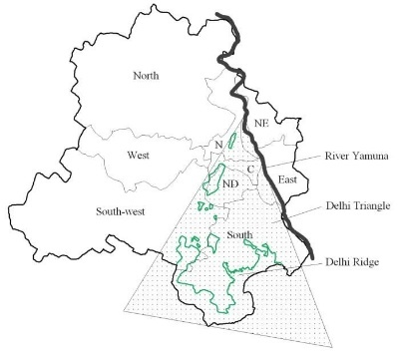
- Application:
  - EC2 corridors between Yamuna riverfront and Ridge Forest could form the green armature.
  - MS2 wildlife crossings could be introduced along NH-8 and NH-24 corridors.
  - PG2 UBIA would be critical in central business district redevelopment zones.
- LCUI Estimated Score: 58% (baseline) – highlights potential for rapid improvement in connectivity and governance.
Pune
- Challenges: Hill-plain interface, seasonal flooding, growing urban heat island
- Application:
  - EF3 rainwater harvesting and EF1 permeable paving in new townships
  - HN4 community co-stewardship in slum upgrading projects like Yerwada
  - PG1 overlay zones could protect fragmented forest tracts in Baner hills
- LCUI Estimated Score: 64% (intermediate) – strong regenerative potential through decentralized stewardship
Bangalore
- Challenges: Aquifer depletion, biodiversity collapse, gentrified greenspaces
- Application:
  - EF5 soil restoration projects in Bellandur, Varthur lakebeds
  - HN1 equitable access initiatives to counter green inequality
  - MS4 habitat restoration for critically endangered Slender Loris
- LCUI Estimated Score: 48% (low baseline) – highest need for multispecies and governance reform
These hypothetical scores are based on composite values of 5 pillars and offer a starting point for institutional diagnostics.

7.3 Comparison with LEED, GRIHA, and Smart City KPIs
Framework | Scope | Ecological Depth | Multispecies Focus | Governance Integration | Relational Equity
LEED | Building-scale sustainability certification | Medium | Absent | Project-based | Limited
GRIHA | Green building code in India | Medium | Limited (flora only) | Developer-led | Minimal
Smart City | Infrastructure & tech integration | Low | Absent | Strong, but tech-focused | Absent
LCUI | Urban ecological benchmarking | High | Central | Governance-embedded | Central
Table 7
Unlike LEED and GRIHA, LCUI does not treat biodiversity or soil as optional metrics. Unlike Smart Cities, it does not equate resilience with technology. LCUI’s strengths lie in its ground-up ecological structuring, multispecies accountability, and open-ended governance pathways.

7.4 Toward Visual Dashboards and Urban Life Reports
The LCUI is designed for transparency. Its indicators can be visualized using:
- Radar charts showing strengths/deficits across five pillars
- GIS-based dashboards for ecological zoning, species corridors, and stewardship areas
- Public scorecards linked to open-data portals and participatory planning platforms

An example Life Report Card for a city could look like:
Pillar | Score (out of 100)
Ecological Continuity | 62
Multispecies Infrastructure | 48
Regenerative Systems | 58
Human–Nature Relationship | 71
Governance & Ethics | 54
Total LCUI Score | 59% (Emerging)
Table 8
These tools allow stakeholders—planners, researchers, communities—to track performance, identify gaps, and build accountability into urban ecological practice.
1. Ecological Continuity
Category Measures:
- Landscape connectivity
- Continuity of blue-green corridors
- Native habitat integrity
- Ecotone resilience (edges between built and natural)
Benchmark Focus:
How well do urban areas support uninterrupted ecological flows (vegetation, soil, water, species)?
2. Multispecies Infrastructure
Category Measures:
- Biodiversity-supportive design (nesting, crossings, foraging zones)
- Co-functional infrastructure (humans + non-humans)
- Species-at-risk accommodation
- Light/noise pollution reduction for fauna

Benchmark Focus:
To what extent is infrastructure designed for cohabitation with non-human species?
3. Regenerative Systems
Category Measures:
- Water and nutrient cycling
- Soil health and microbial activity
- Carbon sequestration
- Urban agriculture integration
- Permeability and absorption capacity
Benchmark Focus:
Are urban systems biologically productive and self-renewing rather than simply low-impact?
4. Human–Nature Relationships
Category Measures:
- Universal proximity to biodiverse greenspace
- Multisensory design inclusion
- Ecological literacy programs
- Community stewardship mechanisms
- Equity in green distribution
Benchmark Focus:
How equitably and meaningfully do people experience, access, and participate in nature?
5. Governance & Ethics
Category Measures:
- Policy enforcement (e.g., zoning, UBIA)
- Institutional presence (e.g., Urban Ecology Units)
- Cross-department coordination
- Public feedback systems
- Transparency in biodiversity and resilience KPIs

Score Range | Category | Meaning
0–29 | Fragile | Critical lack of ecological continuity, multispecies support, and governance. Immediate policy overhaul required.
30–49 | Emerging | Some efforts in place, but fragmented. Basic ecological literacy or greenwashing present. Needs integrated reforms.
50–69 | Transitional | Moderate performance with some regenerative, inclusive, and adaptive systems emerging. Potential to scale.
70–84 | Life-Responsive | Strong implementation of LCUI across pillars. Biodiversity, cohabitation, and governance well integrated.
85–100 | Ecologically Rooted | Exemplary city deeply embedded in life-centric logic. A model of multispecies equity and regenerative governance.
Table 9

CHAPTER 8 CRITICAL REFLECTIONS AND THEORETICAL SIGNIFICANCE

The Life-Centric Urbanism Index (LCUI) offers a novel approach to measuring and guiding urban systems based on ecological continuity, multispecies ethics, regenerative capacity, and relational equity. While it presents a forward-looking and actionable framework, its theoretical and practical significance must be examined through critical reflection. This section explores key limitations, the epistemological shifts it demands, and its original contributions to urban theory and ecological governance.

8.1 Limits: Over-Idealism, Data Gaps, and Market Conflict
A central critique that may be leveled at the LCUI framework is that it risks over-idealism. By proposing indicators that prioritize multispecies cohabitation, ecological zoning, and regenerative metabolism, the framework challenges deeply embedded urban practices driven by real estate capital, infrastructural inertia, and short political cycles. It is unlikely that most cities—especially those in the Global South—have the institutional capacity, ecological data, or cross-sectoral governance structures to operationalize all LCUI indicators immediately.
Moreover, the data necessary for full-scale implementation—such as species-specific migration paths, urban microbial health, or long-term soil quality—is either unavailable, fragmented, or not routinely monitored. While the framework encourages the development of participatory dashboards and ecological monitoring, such tools remain aspirational in many low-capacity urban systems. Without robust data infrastructures, the model may risk becoming an ethical manifesto rather than a replicable urban protocol.
Another limitation lies in its implicit conflict with the speculative logics of capitalist urbanism. LCUI’s insistence on placing ecological and relational metrics over land value or growth efficiency means it directly confronts zoning systems designed to maximize floor area ratios, tax revenues, or logistical throughput. Unless supported by legal mandates or fiscal tools, the framework may struggle to shift behavior at the level of developers, planners, and political stakeholders.

8.2 Epistemological Shift: From Function to Co-Evolution
Despite these limitations, LCUI represents an important epistemological shift in the field of urbanism. Traditional models—whether based on zoning, smart infrastructure, or sustainability certifications—focus on land-use function, economic productivity, or technocratic performance. In contrast, LCUI shifts the analytical lens toward co-evolution, treating cities as dynamic habitats shaped through ongoing negotiation between human and more-than-human actors.
This approach draws from the relational philosophy of thinkers like Beatley, Kellert, and Oliveira, who argue for the reimagining of cities as sites of biodiversity, environmental intimacy, and shared agency. LCUI does not merely advocate for ecological “add-ons”—it asks that ecology be treated as the structuring logic of urban life. This shift is both philosophical and operational: it reframes streets, parks, roofs, and public institutions as multispecies infrastructures, where performance is evaluated not in terms of output or efficiency but in terms of co-habitation, sensory richness, resilience, and care.
Furthermore, the epistemological stance of LCUI acknowledges the plural definitions of nature, as highlighted in Oliveira’s 2025 critique of NBS literature. Nature is not reduced to green surfaces or ecosystem services; instead, it is embraced as a living, contested, place-based reality, co-constituted by indigenous knowledge, cultural practices, species interdependencies, and environmental memory.

8.3 Original Contribution: A Measurable Ecological Ontology
The core contribution of LCUI lies in its translation of life-centric ethics into measurable indicators. While urban ecological theory has matured significantly over the last two decades, it has often lacked quantitative scaffolding. LCUI introduces a measurable ecological ontology—a new way of seeing and evaluating cities not through economic, technical, or carbon-based proxies, but through biological integrity, multispecies access, and feedback-driven governance.
By doing so, it bridges a crucial gap between theory and application. It synthesizes ecological urbanism, biophilic design, nature-based critiques, and posthumanist ethics into an index-based system that can be adapted, localized, and iterated upon. It expands the policy imagination by offering new performance standards, visual scorecards, and stewardship structures that do not erase complexity but institutionalize care.
Ultimately, LCUI’s contribution is not that it claims to solve the ecological crisis. Rather, it offers a lens, a vocabulary, and a system through which urban futures can be imagined, tested, and regenerated—centered not on infrastructure or efficiency, but on life itself.

\

CHAPTER 9 CONCLUSION
The concept of Life-Centric Urbanism emerges at a critical juncture in planning history—a moment when conventional models are faltering in the face of ecological collapse, social fragmentation, and planetary uncertainty. From functionalist zoning to technocratic smart cities, dominant paradigms have treated urban space as a resource to be managed rather than a shared habitat to be nurtured. This research reframes that relationship. It offers the Life-Centric Urbanism Index (LCUI) not as a utopian alternative, but as an evolutionary step—a model that reorients planning toward cohabitation, reciprocity, and systemic regeneration.
Unlike green rating systems that often reduce ecology to quantifiable metrics of energy or carbon, LCUI embodies a deeper logic: that cities must be evaluated by how well they support and sustain life—human and more-than-human alike. It prioritizes empathy, ecological continuity, feedback adaptation, and multispecies ethics as the foundation for urban futures. By introducing measurable indicators across five structural pillars, the framework not only theorizes relational urbanism but renders it actionable, adaptive, and locally testable.
As an ethical project, Life-Centric Urbanism insists that flourishing cannot be exclusive. Green space must be equitably distributed; biodiversity must be preserved across peripheries and cores; and urban metabolism must not simply minimize harm, but actively restore degraded ecosystems. This logic demands policy innovation, ecological zoning overlays, and institutional restructuring—moving from extractive governance to participatory stewardship grounded in ecological justice.
Yet this research also recognizes its own scope and limitations. LCUI is not a blueprint, but a provocation—a call to action for policymakers, scholars, designers, and community stewards to test, iterate, and refine what a truly life-centered city could be. It encourages the launch of pilot studies in small urban clusters, integration of LCUI into academic studios and planning curricula, and development of open-source urban dashboards to monitor, visualize, and communicate life metrics in real time.
In a world increasingly defined by ecological uncertainty, the survival of cities will depend not on control or capital, but on their capacity to reintegrate with the living systems they have long displaced. Life-Centric Urbanism offers a framework—not of resistance, but of re-alignment. It invites us to imagine a future where planning is not just about space, but about care; not just about function, but about co-evolution.

